Topic: Shallow Artificial Neural Network
Tripti Vishwakarma
Colorado State University Global
Course Code CSC 510 -1
Dr Isaac Gang
April 6, 2025

Title: Predicting Sequential Data Using a Handcrafted Artificial Neural Network in Python

Abstract

This paper explores the use of a handcrafted shallow artificial neural network (ANN) to predict sequential data. Utilizing Python and NumPy, the model is designed to accurately forecast the next number in a numeric sequence. The research demonstrates the feasibility of using basic machine learning techniques to achieve high accuracy in sequence prediction tasks, providing insights into potential future applications and improvements.

Introduction
Sequence prediction is a fundamental problem in machine learning with applications ranging from stock price forecasting to natural language processing. This paper investigates the application of a handcrafted shallow ANN, developed using Python and NumPy, to predict the next number in a sequence. The simplicity and efficiency of this approach make it suitable for educational purposes and preliminary research in sequence prediction.

Methods

Data Collection
The model was trained and tested using simple numeric sequences (e.g., 1, 2, 3, 4, 5). These sequences served as both input and output data for the ANN.

Model Architecture
The ANN consists of three layers: an input layer, a hidden layer with 30 neurons, and an output layer. The ReLU activation function was employed in hidden layers to capture non-linear patterns.

Training Process
Data normalization was applied to ensure consistent scaling during training. The model was trained over 2000 epochs using gradient descent and backpropagation to update weights and biases. Adjustments to learning rate and neuron count were made to optimize performance.

Implementation
The following Python code illustrates the implementation of the ANN using NumPy:
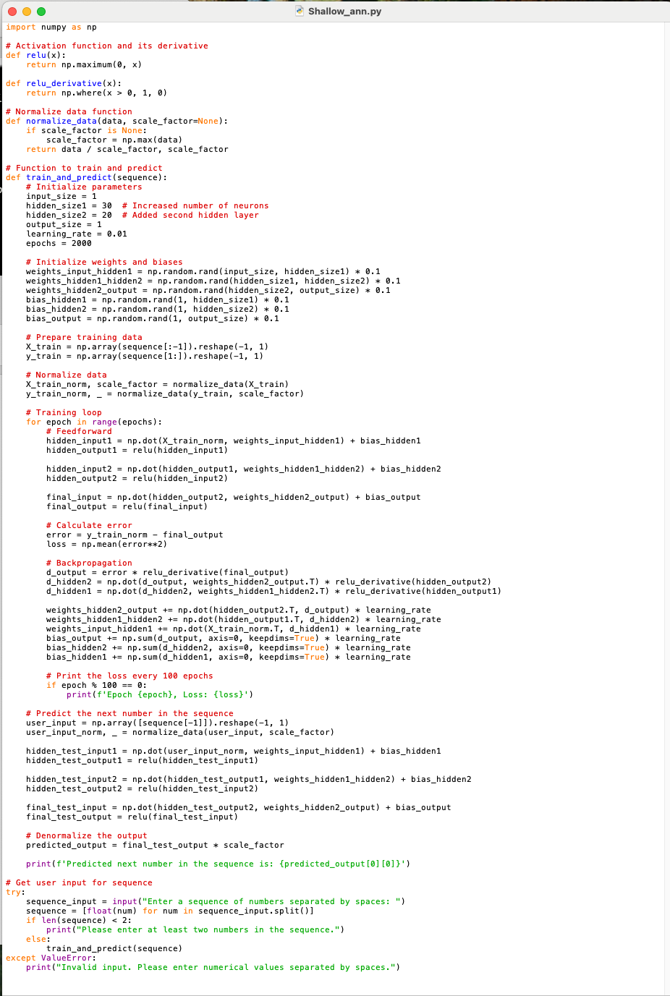

Execution
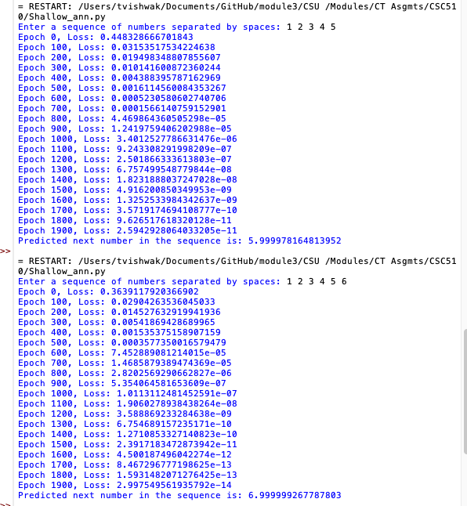

Results
The loss curve demonstrated significant convergence, with loss values decreasing to near zero over 2000 epochs. The model successfully predicted the next number in the sequence with high accuracy, validating the effectiveness of the handcrafted approach.

Discussion
The model's performance highlights the potential of using basic ANNs for sequence prediction tasks. Limitations include the simplicity of the model and potential challenges in generalizing to more complex sequences. Future work may involve exploring more sophisticated architectures such as recurrent neural networks (RNNs) or long short-term memory networks (LSTMs).

Conclusion
This research demonstrates the viability of using a handcrafted shallow ANN to predict sequential data. The approach provides a foundation for further exploration and development of machine learning models in sequence prediction applications.

References

Brownlee, J. (2018). Deep Learning for Computer Vision: Expert Techniques for Advanced Image Analysis. O'Reilly Media. https://learning.oreilly.com/library/view/deep-learning-for/9781788295628/

NumPy Developers. (2023). NumPy Reference. https://numpy.org/doc/stable/

